Gang Violence
Name
Institution
Date

Gang Violence
Abstract
The problem identified in this study is gang violence in the United States of America, especially in Indiana State. The common forms of gang violence in the US include extortion; drug trafficking, theft, robbery and kidnapping. The factors leading to the occurrence of gang violence encompasses increment in youth population, inadequate housing, drug and alcohol abuse, a high unemployment rate, lack of education, poverty, poor parenting skills, loss of culture, language and identity (Ambrosius, 2018). The exact committed crime that stimulated the onset of this study is car theft in Bloomington city within Indiana State committed by Paul Warden and his gang. The participants, in this case, include the victims of crimes, the Indianapolis, judges and magistrates, the family of inmates in Indiana prisons. This society encompasses people who have been subjected to crimes. The methods used in the collecting of information include cell phone interviews and face to face interviews. Generally, the qualitative approach was commonly used, but in the collection of statistics, the quantitative approach was used. The basic findings of the study are that gang violence cases lie in the level six felony. Additionally, the crimes affect victims by initiating depression, financial strains, and at times lead to physical injuries. More significantly, the elimination of violence is a collective responsibility, and all the stakeholders in security should be active in minimizing the crimes. The organization of this paper will start with Federal/ state statue & sentencing, statistics related to car theft, effects of the crime on the victim, results of the crime on the society, and ways of reducing crime victimization.

Federal/ State Statue & Sentencing
The United States of America is governed by both federal and state laws. The federal laws are controlled by the national government and applicable in all the parts of the US. The state laws are applicable within the boundaries of the nations they are made, and thus they are also helpful in maintaining order. Additionally, there is the statute which is a formal written enactment of the legislative authority that governs the legal entities of a state. In this case, our greater concern is in the statute of Indiana State (Hofer, 2019). The federal government gives clear regulations that help the state government in deciding what should happen or how cases should be determined. For example, the criminal acts are categorized under felonies whose offences may lead to prison sentence exceeding one year and the other categorized under misdemeanors carrying sentence for one year or less. Therefore, the case on car theft gang violence lies under the category of a misdemeanor as well as a felony as per the Indiana state statue. On the side of a misdemeanor, the case can be punishable by at least six months in jail. On the other side of a felony, the case can be punishable by as much as two and a half years of imprisonment and a fine not exceeding $ 10,000. More significantly, this type of gang violence is coded; Ind. Code Ann. § 35-50-2-7 in the Criminal Code Book (Hofer, 2019).
Statistics on Car Theft in the United States of America
In the US, almost $6 billion are lost to motor vehicle theft annually (Hofer, 2019). However, this number varies by a margin, and it will either increase or decrease by a rate of about 4%. The California state has the highest number of motor vehicle in the United States. Recently, the incidences of car theft have been on the increase. The most stolen car is Honda Civic, and this is because of its exciting features which attract thieves the most. In the Vermont state, the level of care theft is minimal as compared to all the other states (FBI National Press Office, 2019). Most motor vehicle thefts happen during the popular days in the United States. During the commemoration new year, at least 2,469 were stolen in the year 2018. In the Indiana state, the rate of motor vehicle theft has been on the increase. In the year 2017, 14,738 vehicles were stolen (Insurance Information Institute, 2019). This number increased to 15,328 cars in 2018. However, Indianapolis has been active and enforcing the law to minimize the incidences of gang violence in the state. The common assumption on the incidences of unreported crime cases in the US is about 3 out of 4 (Alvarez, & Bachman, 2019). However, the cases of motor vehicle theft are commonly reported as compared to all the other crimes.
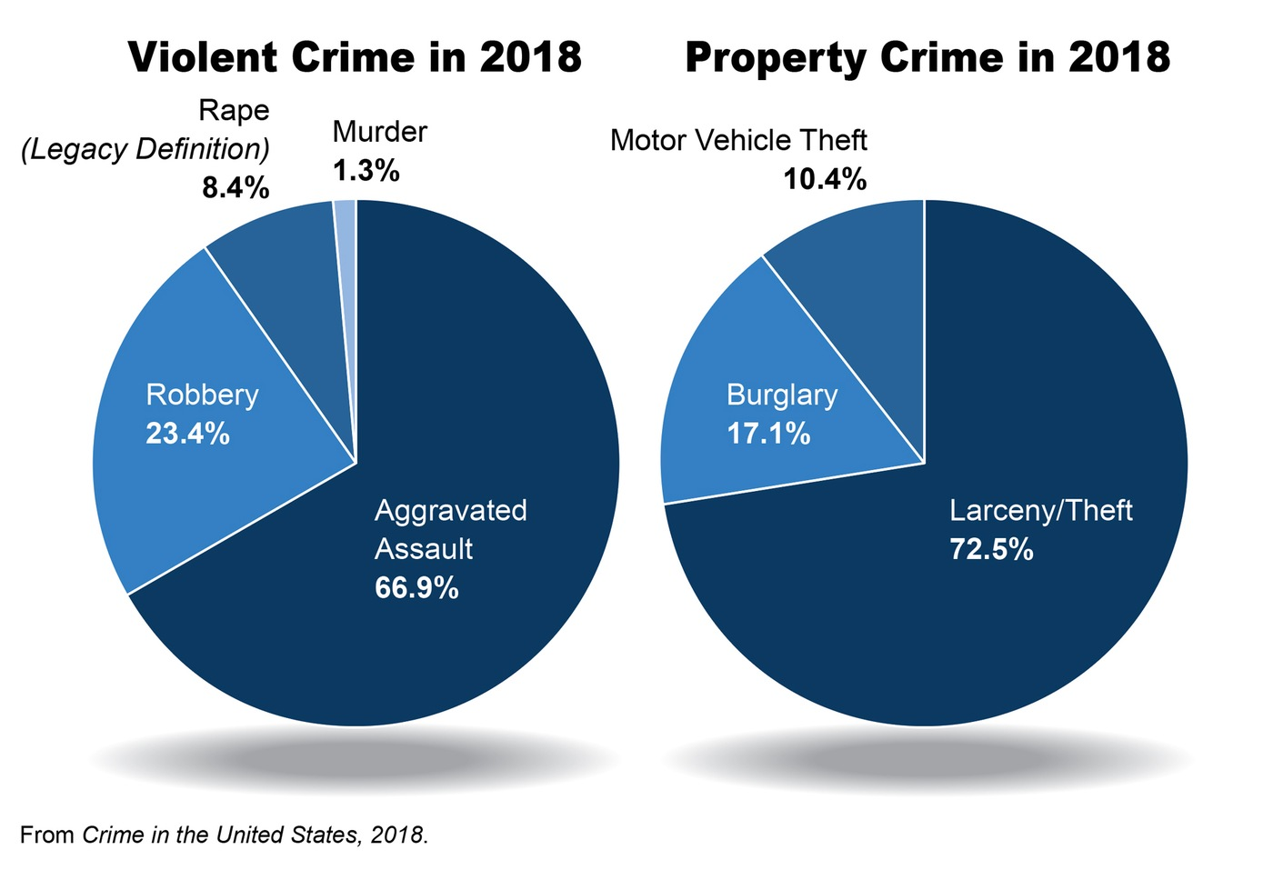
Fig. 1.1. Images on crimes in United States of America
Effects of the Crime on the Victim
Crimes will always have effects on the victims, either positive or negative. However, in most cases, crimes lead to adverse impacts on both the victim and his or her family. The case of Paul Warden on car theft landed him into personal harm, including depression and fear of the Indianapolis since for three months, he was hiding in fear of being arrested (Ambrosius, 2018). Additionally, during the process of thefts, Paul suffered broken harm as a result of banging the car door, and he decided not to seek hospital medication. Thus he was being attended to by a close friend and a member of his gang. Since then, Paul has been depicting signs of insomnia, and this proves his level of depression. However, it was not the first time Paul was involved in violence. He has been accused of incidences of drug trafficking, although the evidence provided for these cases have always been rendering insufficient to prove him guilty. More surprisingly, Paul was arrested at a time when he was the only breadwinner in his family since his wife was expectant, and their firstborn son was about to celebrate his sixth birthday. At long last, Paul was subjected to the law and imprisoned for two years and fined $ 10,000, and this period exposed his family to a hard time of financial strain.
Effects of the Crime on the Society
The community and government spent a considerable amount of public funds for police departments in financing the investigations. As well, Paul had to be taken to proper medical attention to fix his broken harm, and this is extra expenses (Carson &Esbensen, 2017). People in society were also in fears of losing their property after the incidence of care theft was reported. The more people are aware of a crime, the more they tend to be afraid of becoming victims of the crime.

Ways of Reducing Crime Victimization
All the societies are aware of criminal activities, and this needs them to perform activities that will help them in minimizing victimization. The most significant thing in reducing crimes is by offering advice to the offender and warning them on the effects of the crimes. Nevertheless, society needs to take caution and seal all the loopholes that attract criminals. In this case, people should park in a secure area, and the car doors locked (Carson &Esbensen, 2017). As well, people should avoid the areas unfamiliar to them, and this will reduce the incidences of exposure to theft. As well, the society should take part in eliminating all sorts of crimes by reporting to the police officers on any incidences of crime for investigation. The laws need to be enforced effectively, and judgment in the criminal offences made immediately after the criminals are arrested. The punishment should be in line with the laws of the state.
Conclusion
In summation, gang violence is common in all places in the world and includes thefts, robbery and drug trafficking. The case described in this paper regards car theft in the Indiana state by a gang led by Paul Warden. This crime is classified under level six felonies, and thus Paul was subjected to two years’ imprisonment and a fined $ 10,000. The statistics on car theft imply that California State is the leading state in car theft. Generally, this crime has been on the increase currently. In the Indiana state, the rate of motor vehicle theft has been on the rise. In the year 2017, 14,738 vehicles were stolen. This number increased to 15,328 vehicles in 2018. Crimes have adverse effects on both the victims and society (Insurance Information Institute, 2019). In most case, the victims are subjected to depression, financial strain and suffering of close relatives. The society lives in fears over the occurrence of similar crimes. However, limiting the crimes is a collecting responsibility. It needs the people to report the cases of violence, the police getting hyper-active in arresting the criminals and public avoiding victimization from streets and parking in secure places.

References
Alvarez, A., & Bachman, R. D. (2019). Violence: The enduring problem. SAGE Publications, Incorporated.
Ambrosius, C. (2018). Deportations and the roots of gang violence in Central America. Criminal Justice, Borders and Citizenship Research Paper, (3225314).
Carson, D. C., &Esbensen, F. A. (2017). Prevalence, risk factors, and pathways to gang violence. The Wiley Handbook of Violence and Aggression, 1-12.
FBI National Press Office. (2019). FBI releases 2018 crime statistics. Retrieved by https://www.fbi.gov/news/pressrel/press-releases/fbi-releases-2018-crime-statistics
Hofer, P. J. (2019). Federal Sentencing after Booker. Crime and Justice, 48(1), 137-186.
Insurance Information Institute. (2019). Facts, and statistics: Auto theft. Retrieved from https://www.iii.org/fact-statistic/facts-statistics-auto-theft

